Multimedia Web Design Homework
HTML&CSS EXERCISES (week 6)
Layout, Animations & Responsive Design — Making It Perfect

Eda Selmani – Computer Engineering
Exercise 1: Apply Flexbox to Your Portfolio Layout
- ABOUT SECTION: Wrap your profile image and bio in a div.about-content. Apply display: flex, gap: 40px, align-items: flex-start. Image: flex: 0 0 200px. Text: flex: 1.
- SKILLS SECTION: Wrap skill items in div.skills-flex. Apply display: flex, flex-wrap: wrap, gap: 12px. Each skill item gets flex: 1 1 150px, padding: 12px, border-radius: 6px.
- HEADER: Make your header a flex column — center name and nav vertically and horizontally.
- Test the magic: shrink your browser window and watch flex items wrap naturally.
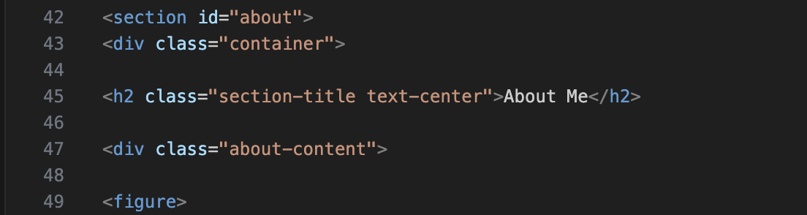
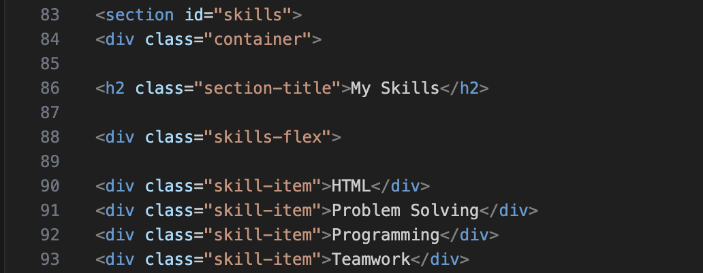

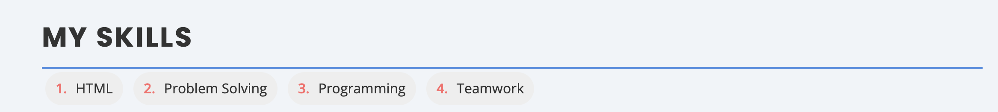
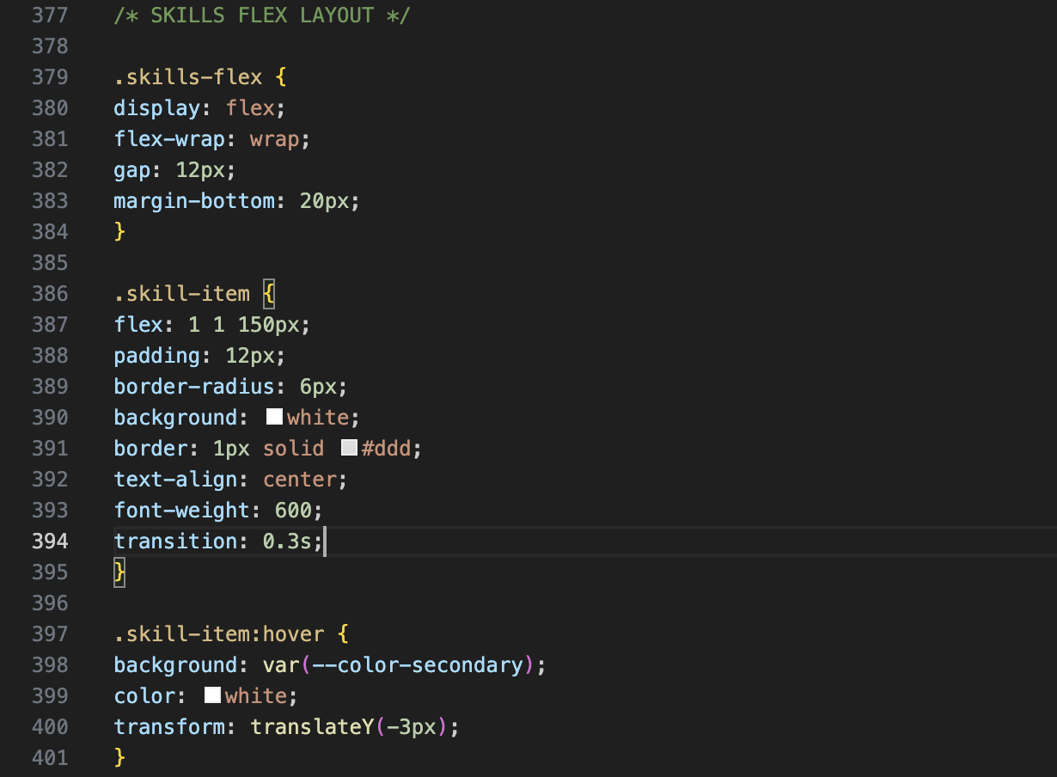

Exercise 2: Rebuild Projects with CSS Grid
- In index.html, convert your projects section to a grid of cards. Create 3+ div.project-card elements inside div.projects-grid. Each card: title (h3), description (p), link (a).
- In style.css, add the .projects-grid and .project-card styles with your own color variables.
- Add the hover effect: transform: translateY(-6px) and deeper box-shadow with transition.
- BONUS: Try grid-template-areas to create a full page layout with header spanning full width, sidebar, main, and footer.
- Resize the browser — your grid should automatically adjust the number of columns!
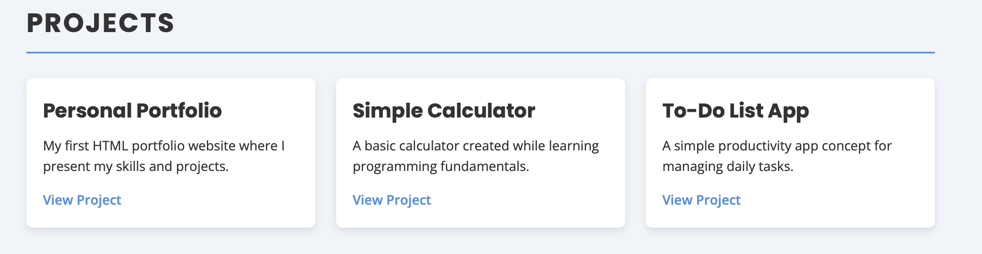
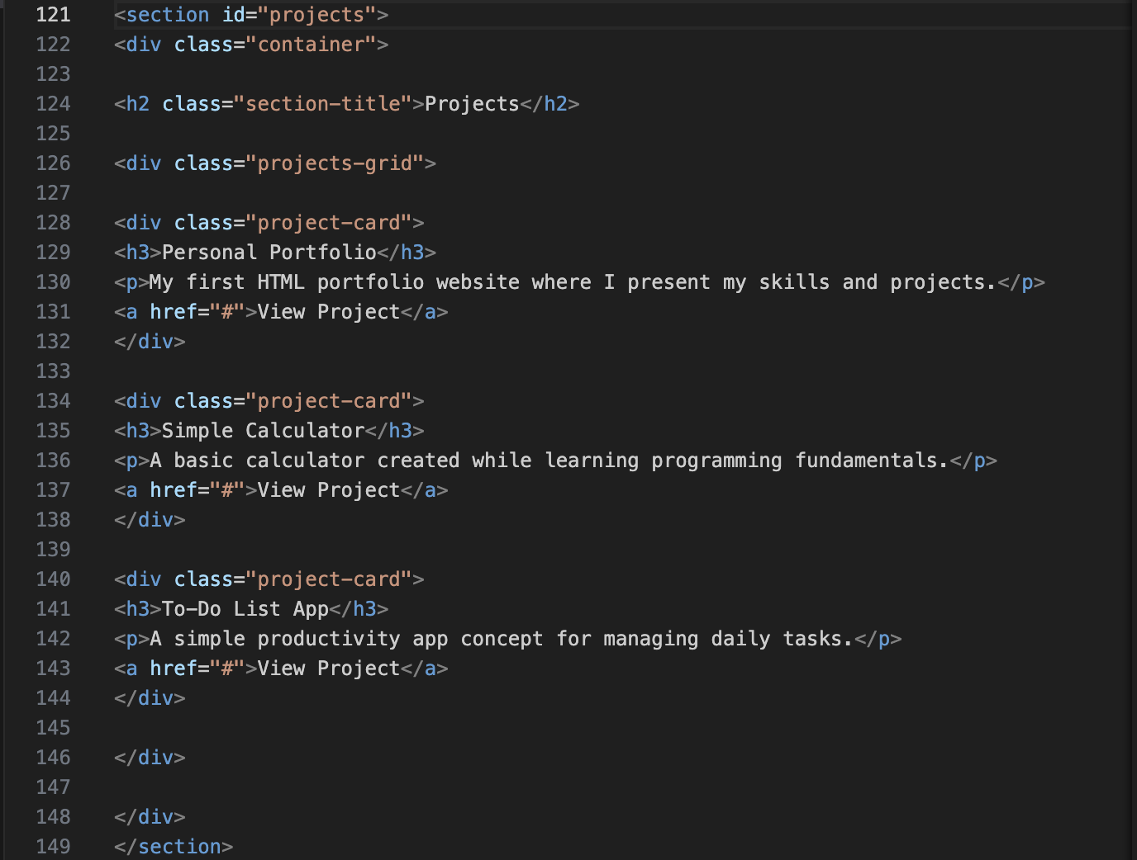
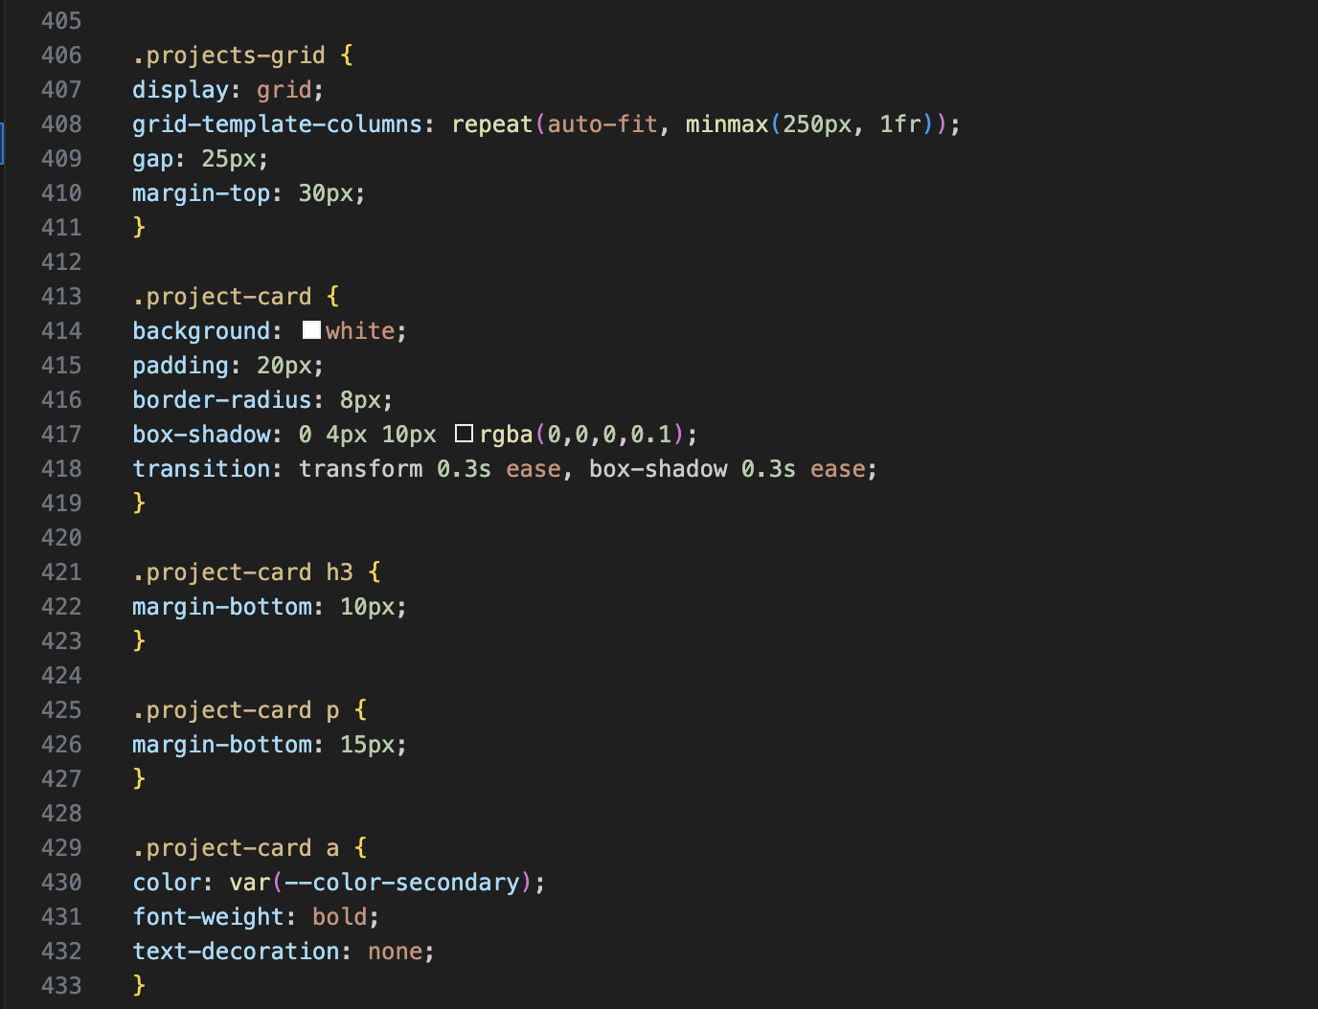
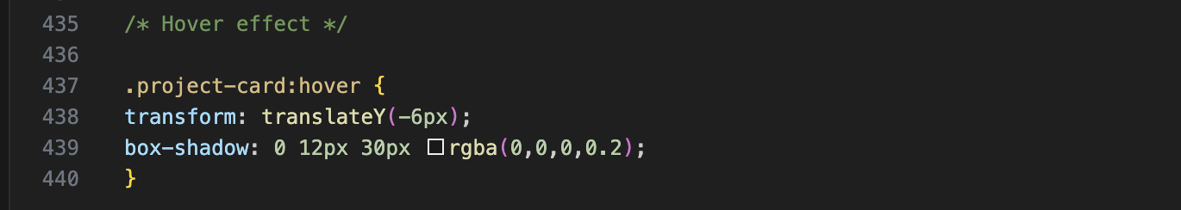

Exercise 3: Fix Your Navigation and Add a Hero Section
- STICKY HEADER: Give your <header> position: sticky, top: 0, and z-index: 100. Scroll the page — the header should stick to the top!
- HERO SECTION: Add <section id='hero'>. Give it: min-height: 100vh, display: flex, flex-direction: column, justify-content: center, align-items: center, text-align: center, and your gradient background.
- BACK-TO-TOP BUTTON: Create <a href='#hero' class='back-to-top'>↑</a> before </body>. Style with position: fixed, bottom: 30px, right: 30px, background accent color, border-radius: 50%, 44px width/height.
- Add a 'NEW' badge on a project card using position: absolute on a <span> inside position: relative on the card.
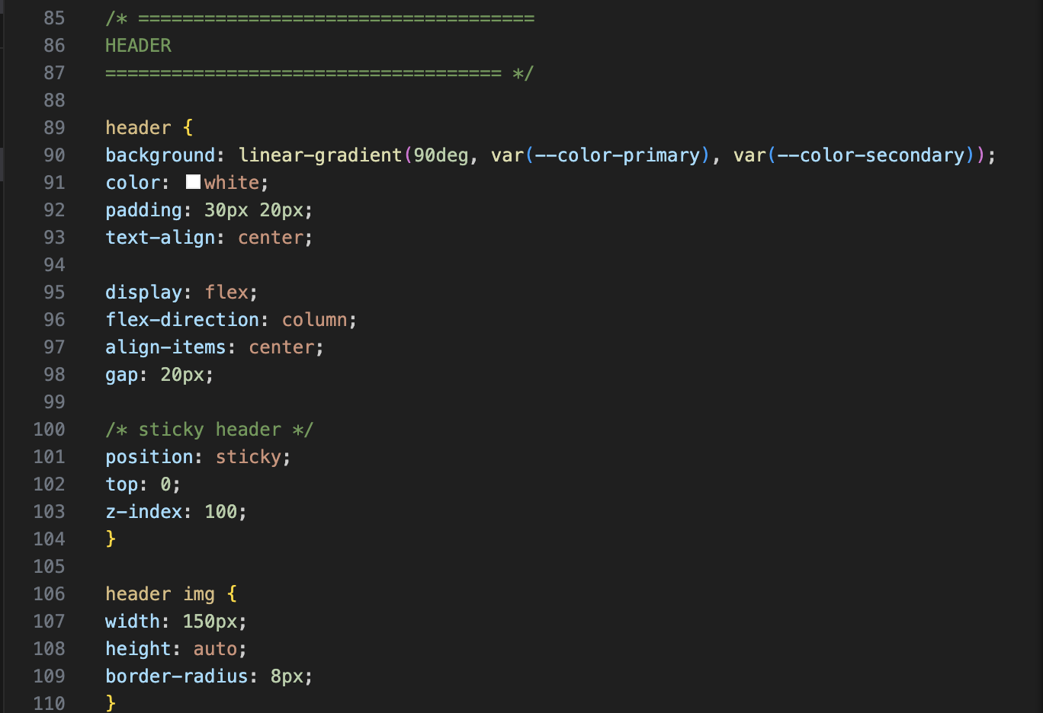
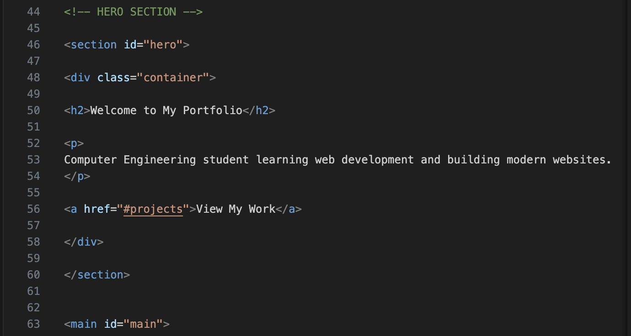
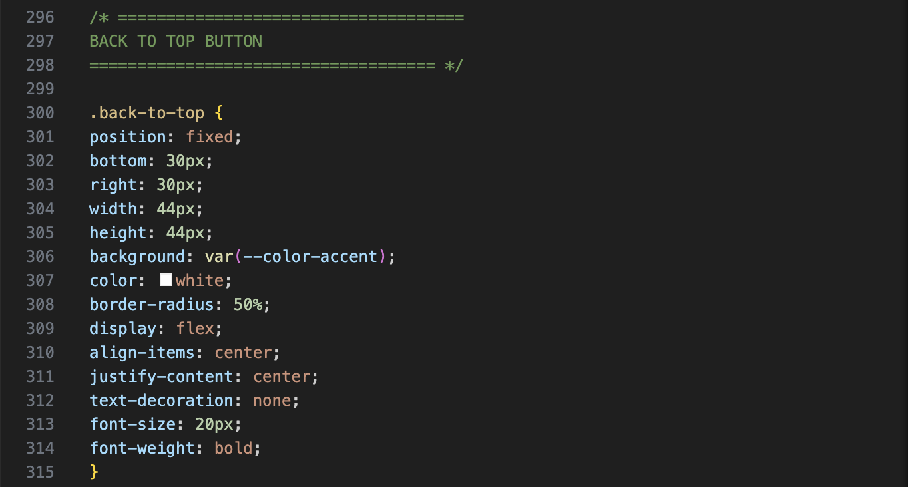


Exercise 4: Add Animations to Your Portfolio
- HERO ENTRANCE: Add fadeIn @keyframes. Apply to hero h1 (no delay), tagline (0.3s delay), button (0.6s delay).
- CARD HOVER: Project cards should translateY(-6px) and increase box-shadow on :hover with transition: transform 0.3s ease, box-shadow 0.3s ease.
- SKILL TAGS: Give each skill tag a :hover that changes background-color and scales to scale(1.05).
- NAV LINKS: Add transition so background-color change on :hover is smooth (0.3s ease).
- SUBMIT BUTTON: On :hover translateY(-2px). On :active translateY(0) — feels like a real button press.
- BONUS: Add @keyframes pulse to a 'Hire Me' button or contact link to draw attention.
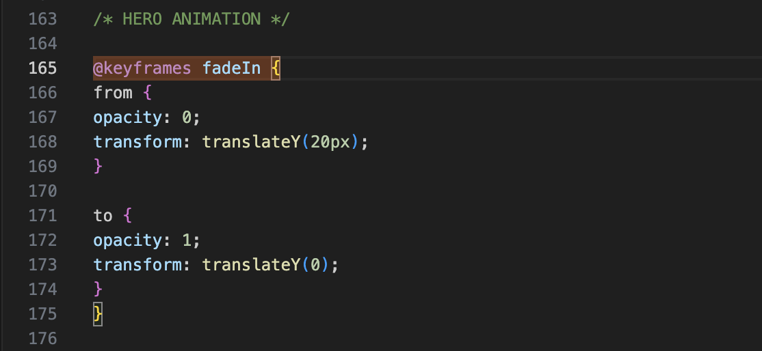
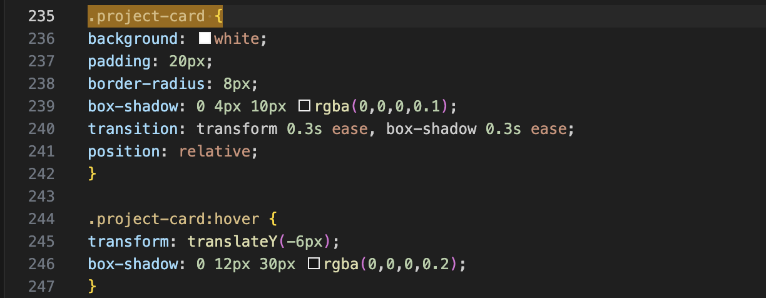
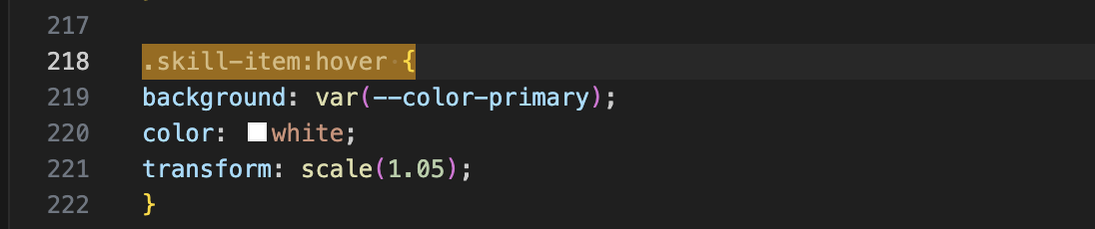

Exercise 5: Make Your Portfolio Fully Responsive
- MOBILE BASE: Remove fixed widths. Make .projects-grid use 1 column, .about-content use flex-direction: column. Set smaller mobile font sizes (h1: 2rem, h2: 1.5rem).
- TABLET (min-width: 768px): Add media query. Change nav to flex-direction: row. Change .about-content to row. Change .projects-grid to 2 columns.
- DESKTOP (min-width: 1024px): Change .projects-grid to 3 columns. Set larger headings. Set .container max-width: 1100px.
- Add img { max-width: 100%; height: auto; } globally.
- Open DevTools, click the responsive icon. Test at iPhone SE (375px), iPad (768px), Desktop (1280px). Fix any broken elements.
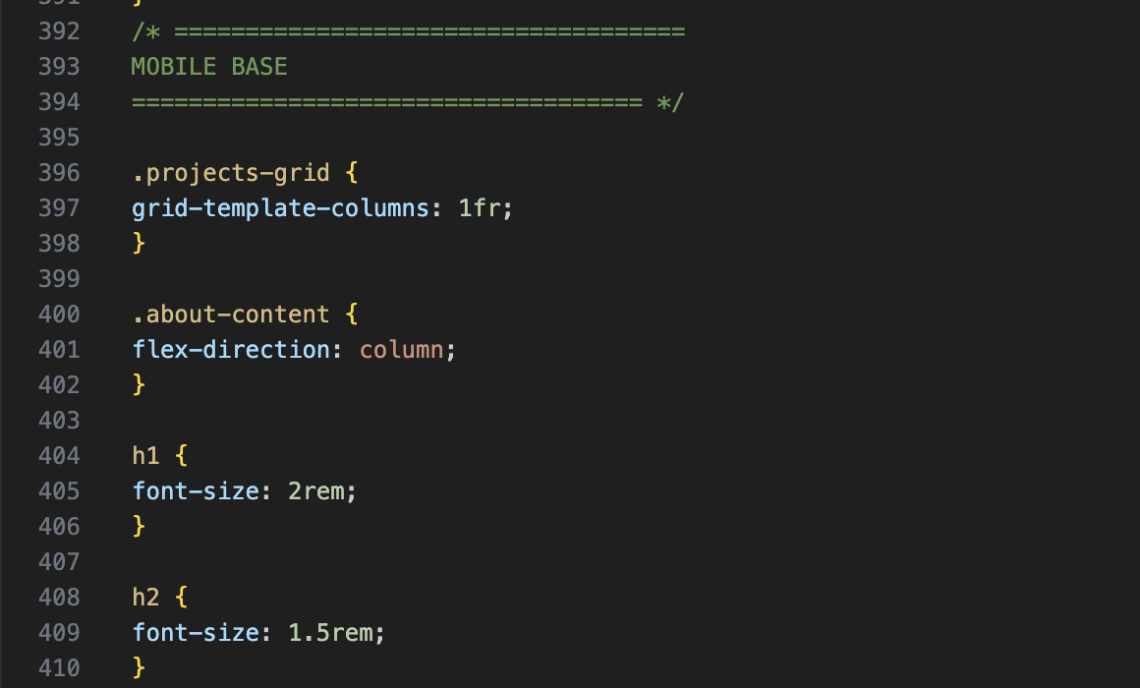
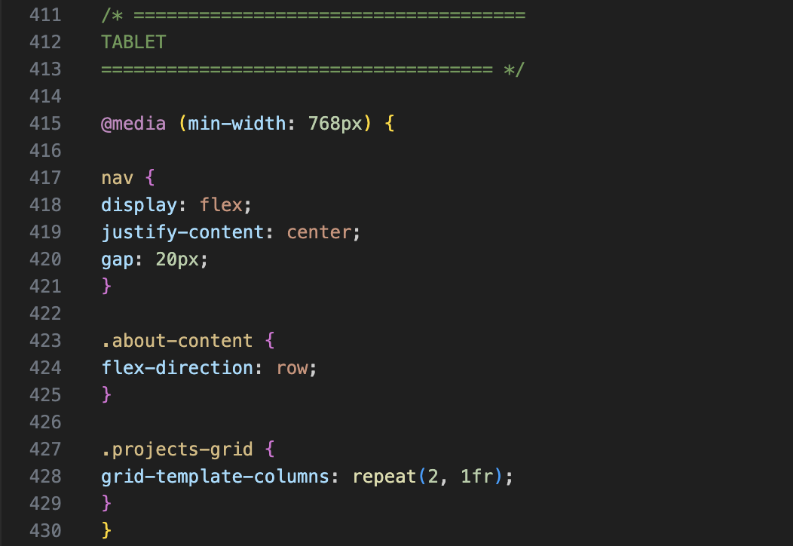
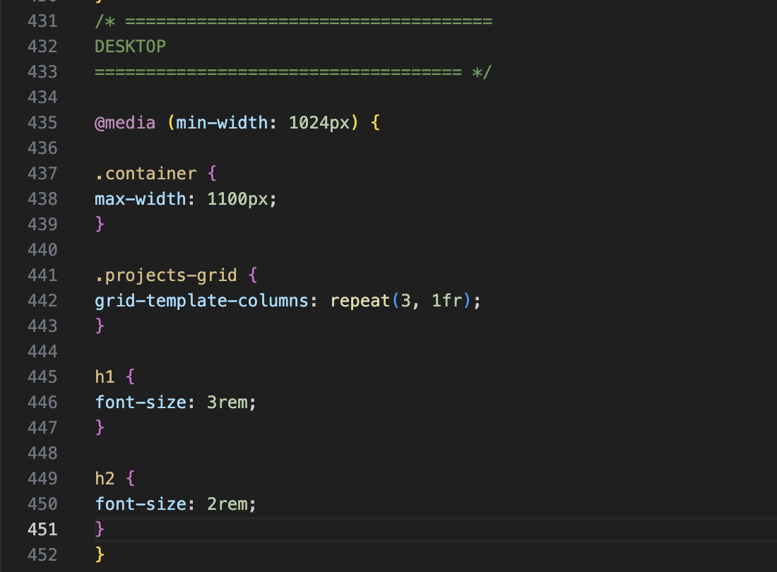

Exercise 6: Polish with Shadows, Filters & Variables
- Update :root with shadow variables: --shadow-sm, --shadow-md, --shadow-lg. Replace all box-shadow values in your CSS.
- Add spacing variables --space-sm through --space-xl and update padding/margin values to use them.
- Give your profile image filter: grayscale(80%) that removes on :hover with transition: filter 0.4s ease.
- Add box-shadow to ALL cards using your variables. Shadow deepens on :hover.
- Give hero section a dark overlay using .hero::before { content: ''; position: absolute; inset: 0; background: rgba(0,0,0,0.4); } (hero needs position: relative).
- Apply filter: drop-shadow() to any SVG icon or PNG logo.
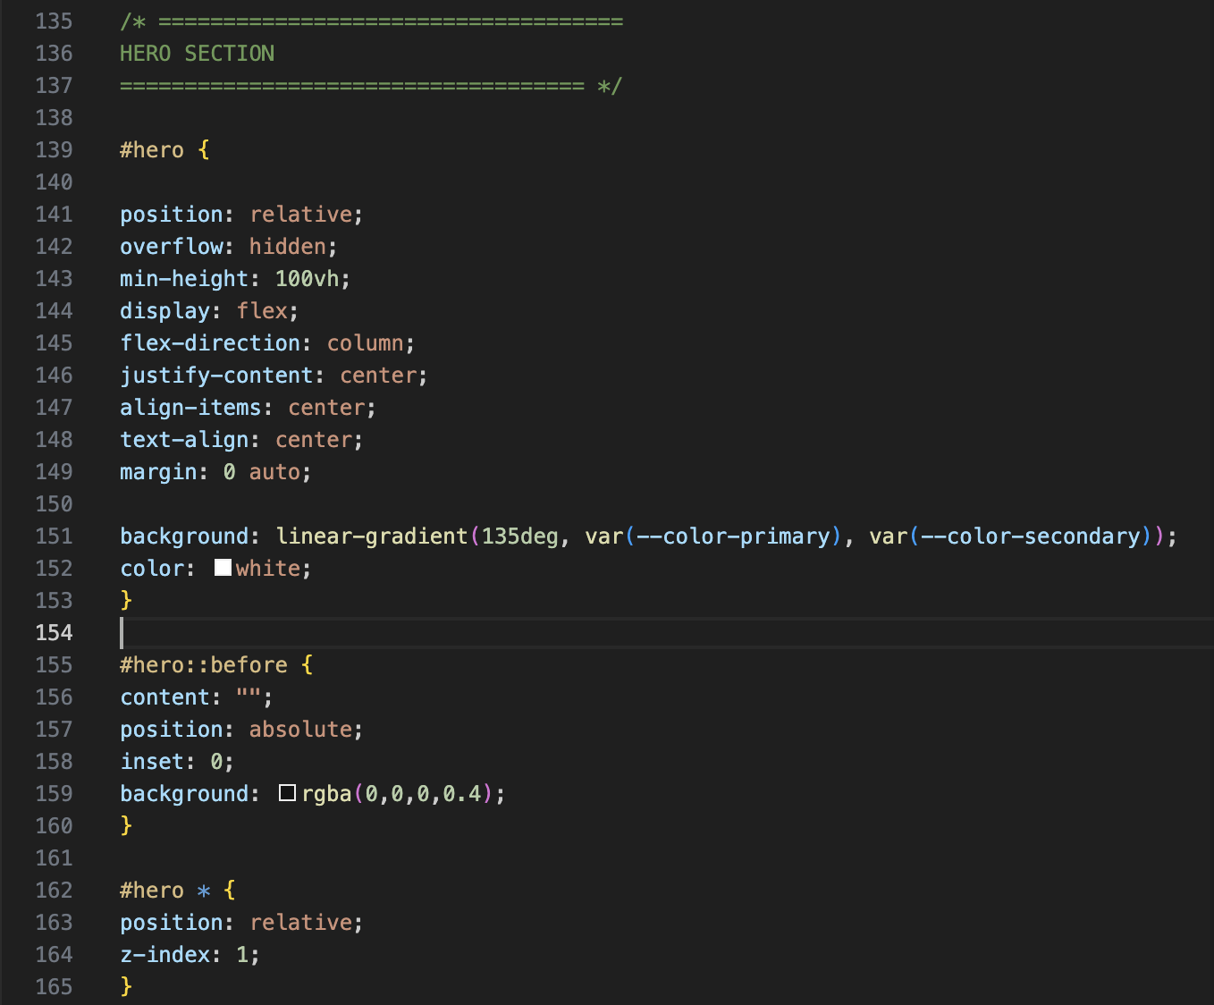


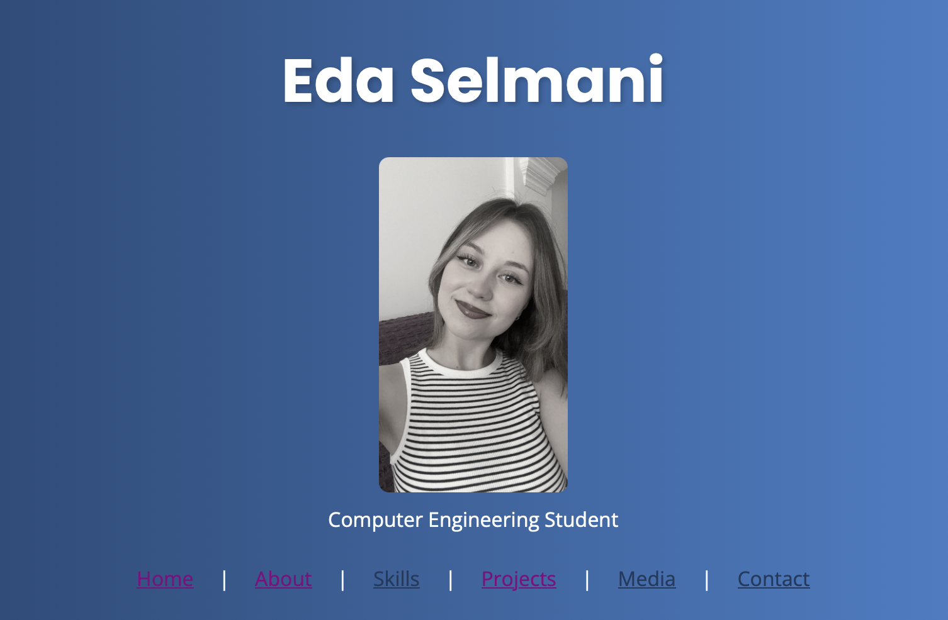

Exercise 7: Use Multi-column Layout
- Add a text-heavy 'About Me' or 'Blog Preview' section to your portfolio.
- Apply column-count: 2 and column-gap: 40px on tablets (768px+) and column-count: 1 on mobile.
- Add a column-rule: 1px solid #e0e0e0 as a visual separator between columns.
- Use column-span: all on the section heading so it spans the full width.
- BONUS: Apply break-inside: avoid to cards inside a multi-column layout so they never split across columns.
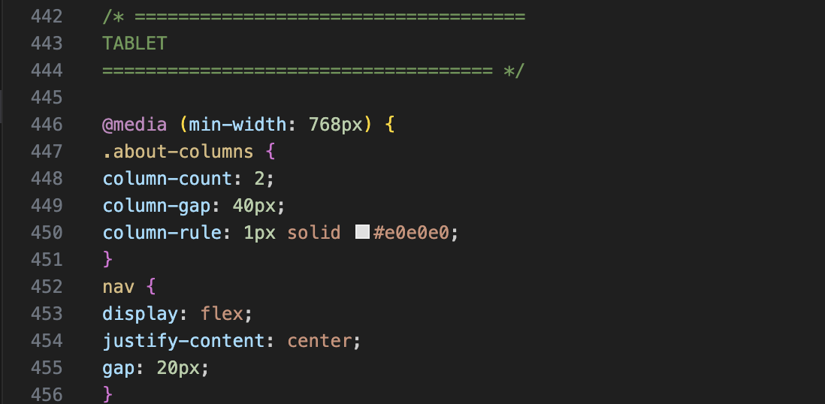
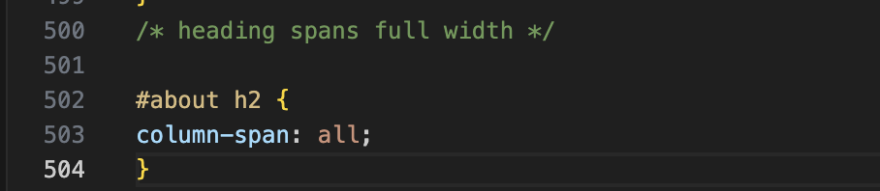
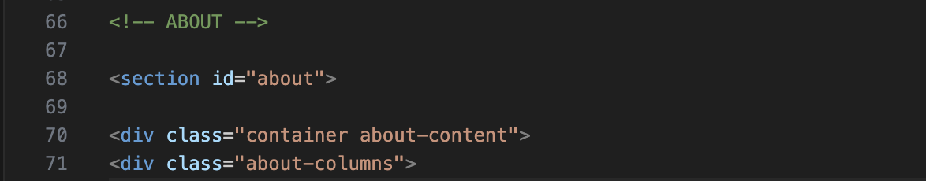

Exercise 8: Enhance UI Details in Your Portfolio
- Add html { scroll-behavior: smooth; } so clicking nav links smoothly scrolls to sections.
- Add cursor: pointer to all buttons, nav links, and clickable cards.
- Set textarea { resize: vertical; } on your contact form textarea.
- Add a custom scrollbar style using ::-webkit-scrollbar properties matching your color scheme.
- Replace any outline: none with :focus-visible styles to maintain keyboard accessibility.
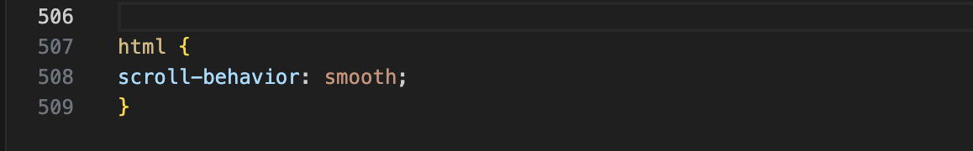
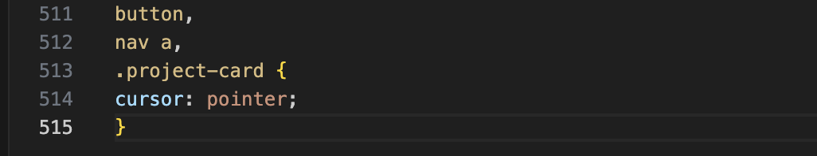
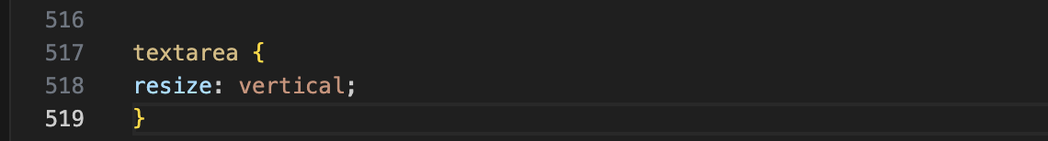
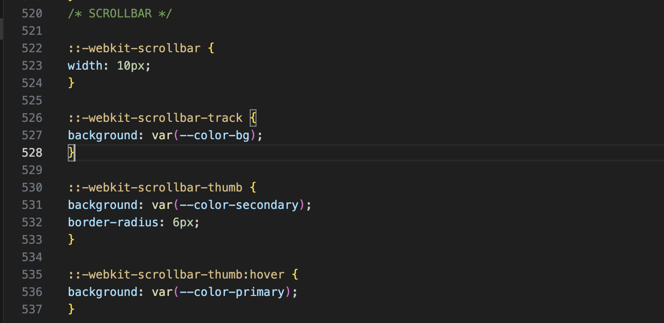
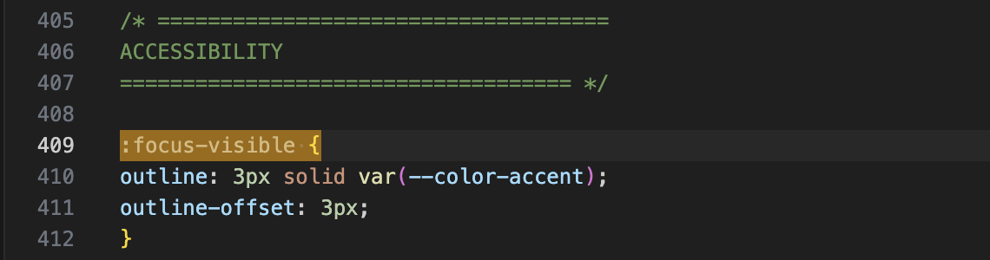
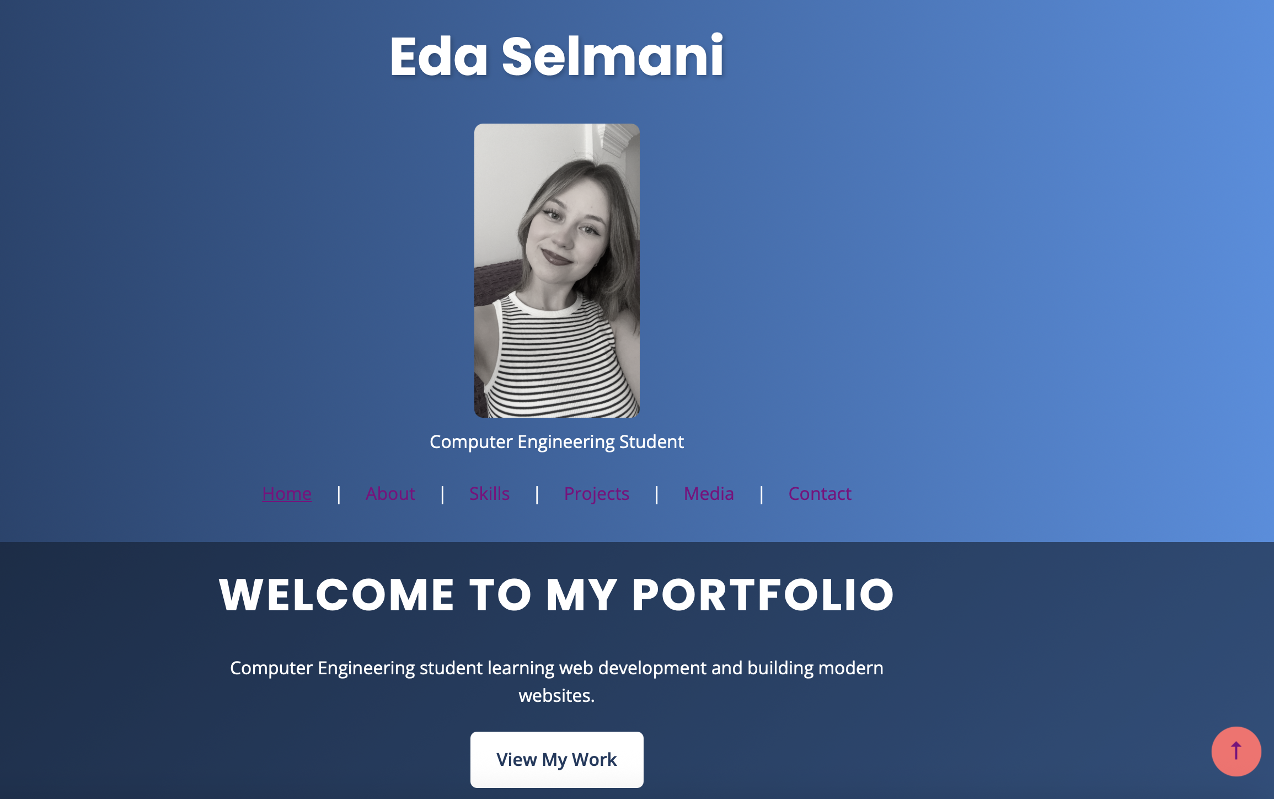
Exercise 9: Use @supports and @property
- Wrap your CSS Grid layout in an @supports (display: grid) block. Add a flexbox fallback outside it for older browsers.
- Use @supports (backdrop-filter: blur(10px)) to add a frosted-glass effect to your sticky header: backdrop-filter: blur(10px); background: rgba(255,255,255,0.8);
- BONUS: Define a @property --card-hue and animate it on hover to create a color-shifting card effect.
- Open DevTools → Console and type CSS.supports('display', 'grid') to see feature support programmatically.
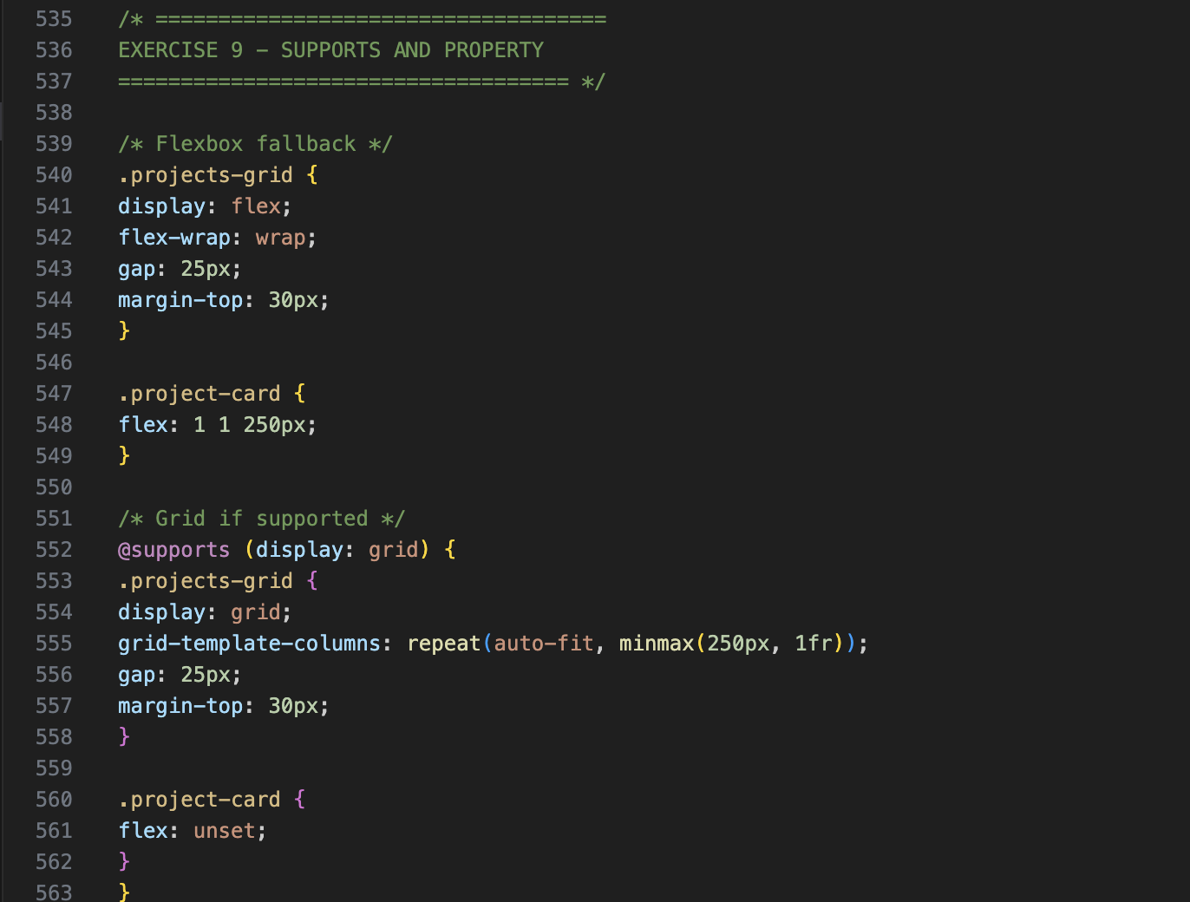
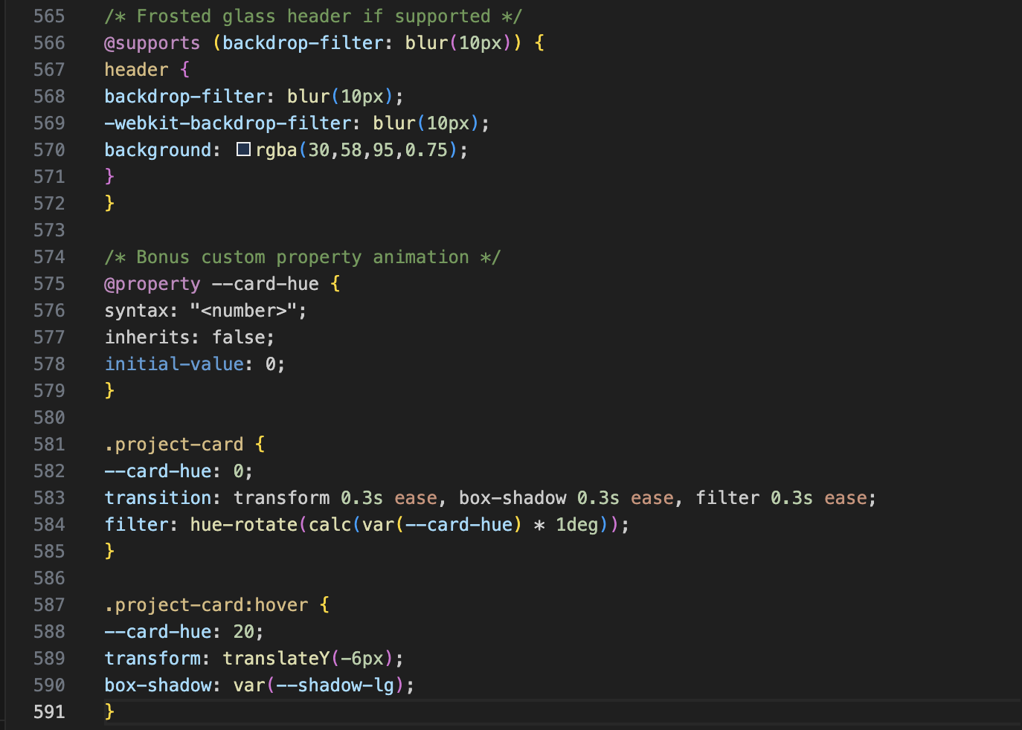
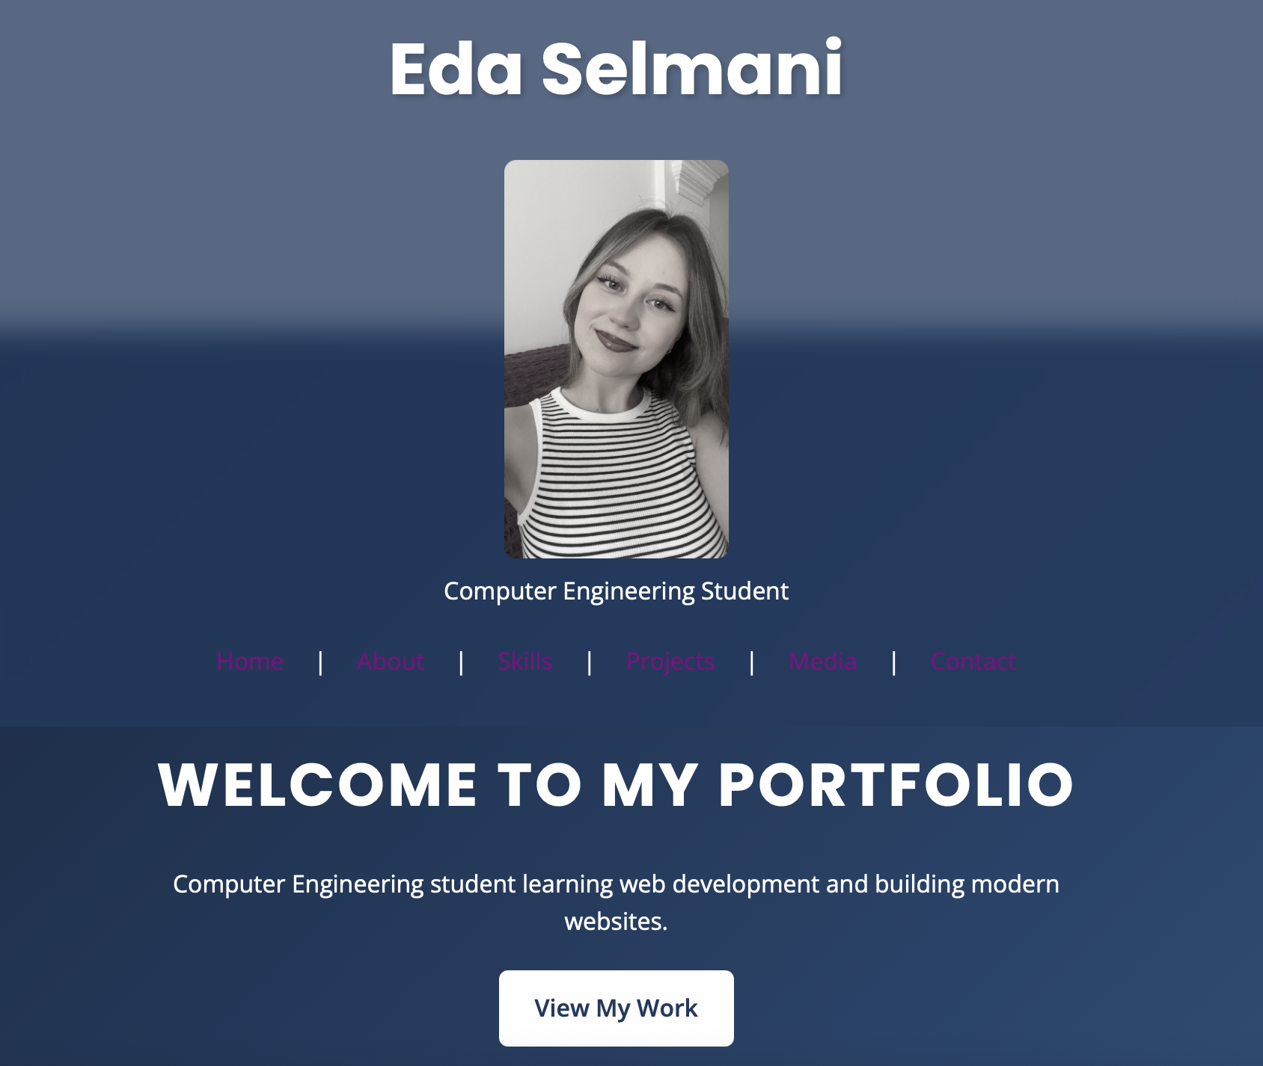
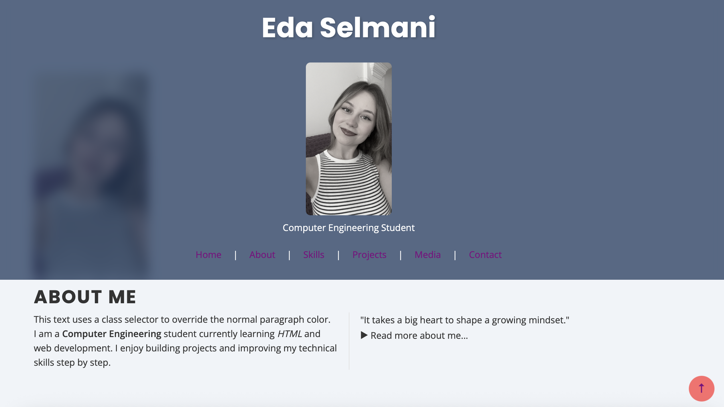

Exercise 10: Style Your Portfolio Images
- Add a profile photo to your About section. Apply border-radius: 50% to make it circular. Add a box-shadow and a grayscale filter that removes on :hover.
- Apply object-fit: cover and a fixed height to any project thumbnail images so they all display consistently.
- Add a hover overlay to one project card showing a 'View Project' label using position: absolute and opacity transition.
- BONUS: Apply clip-path: polygon() to the hero section background image for a modern slanted design.
- Use filter: drop-shadow() on any PNG logos or SVG icons for a subtle depth effect.
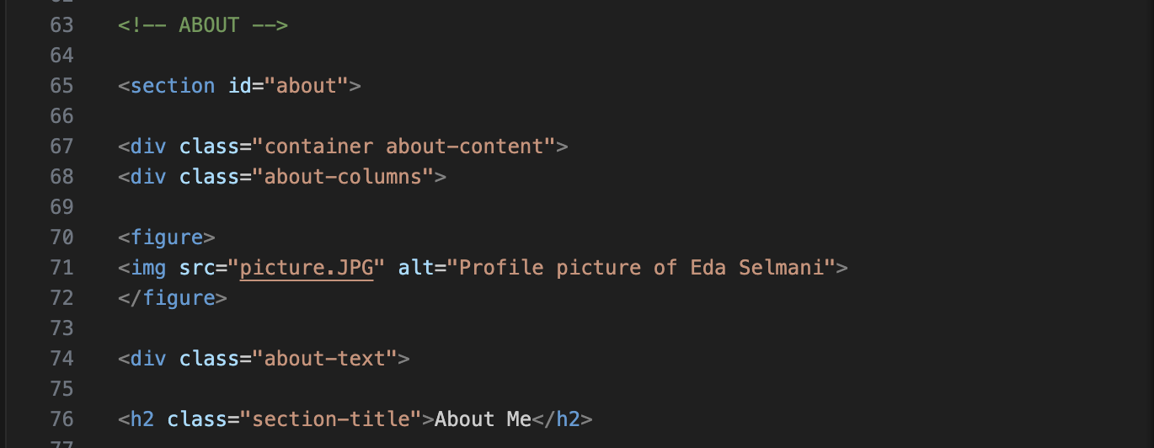
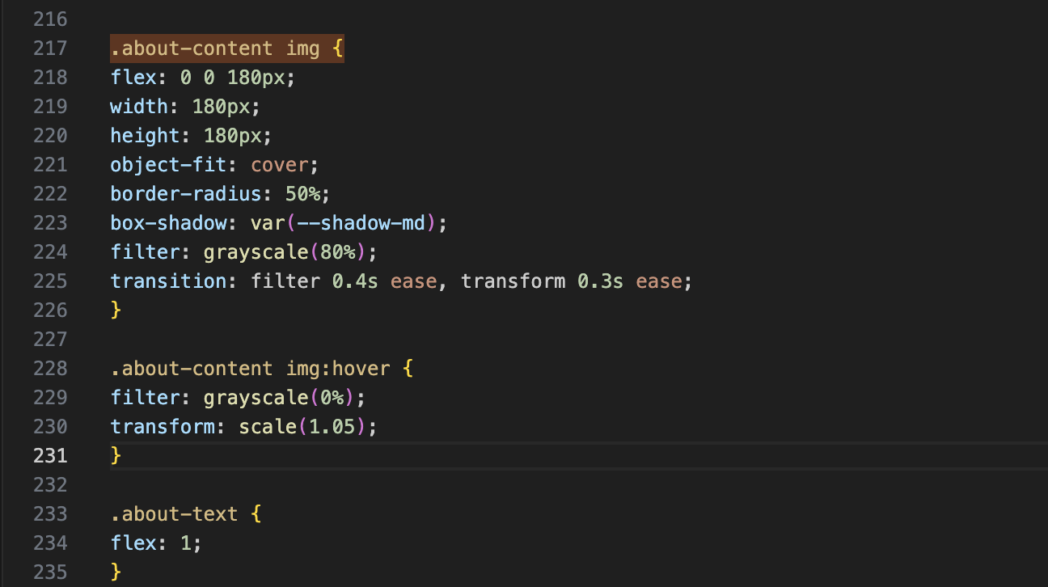
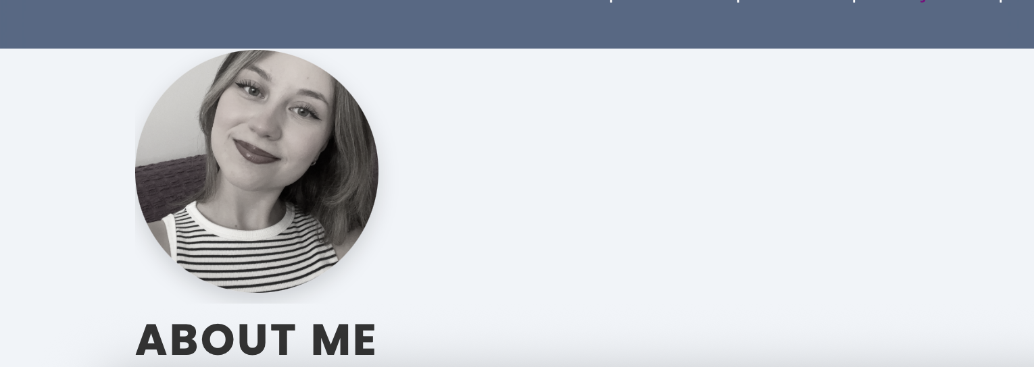

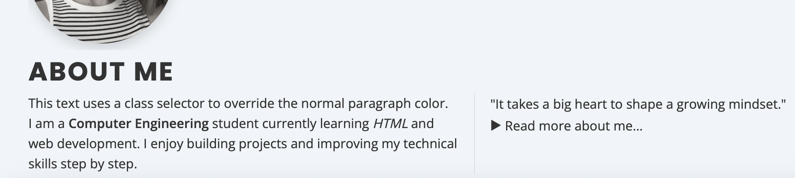
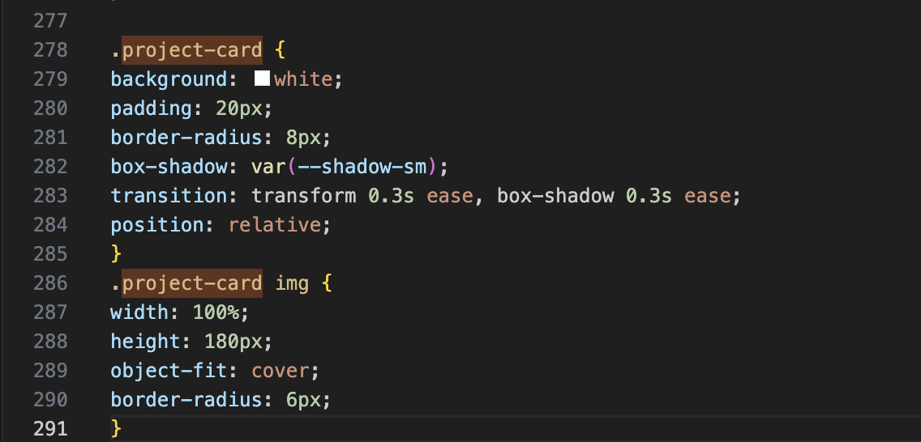
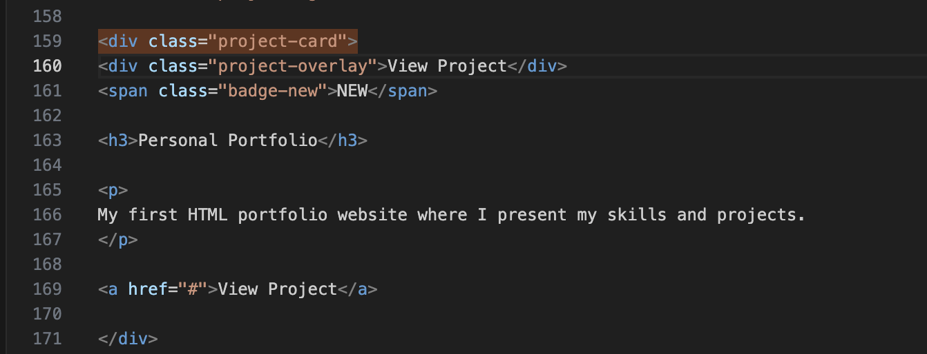
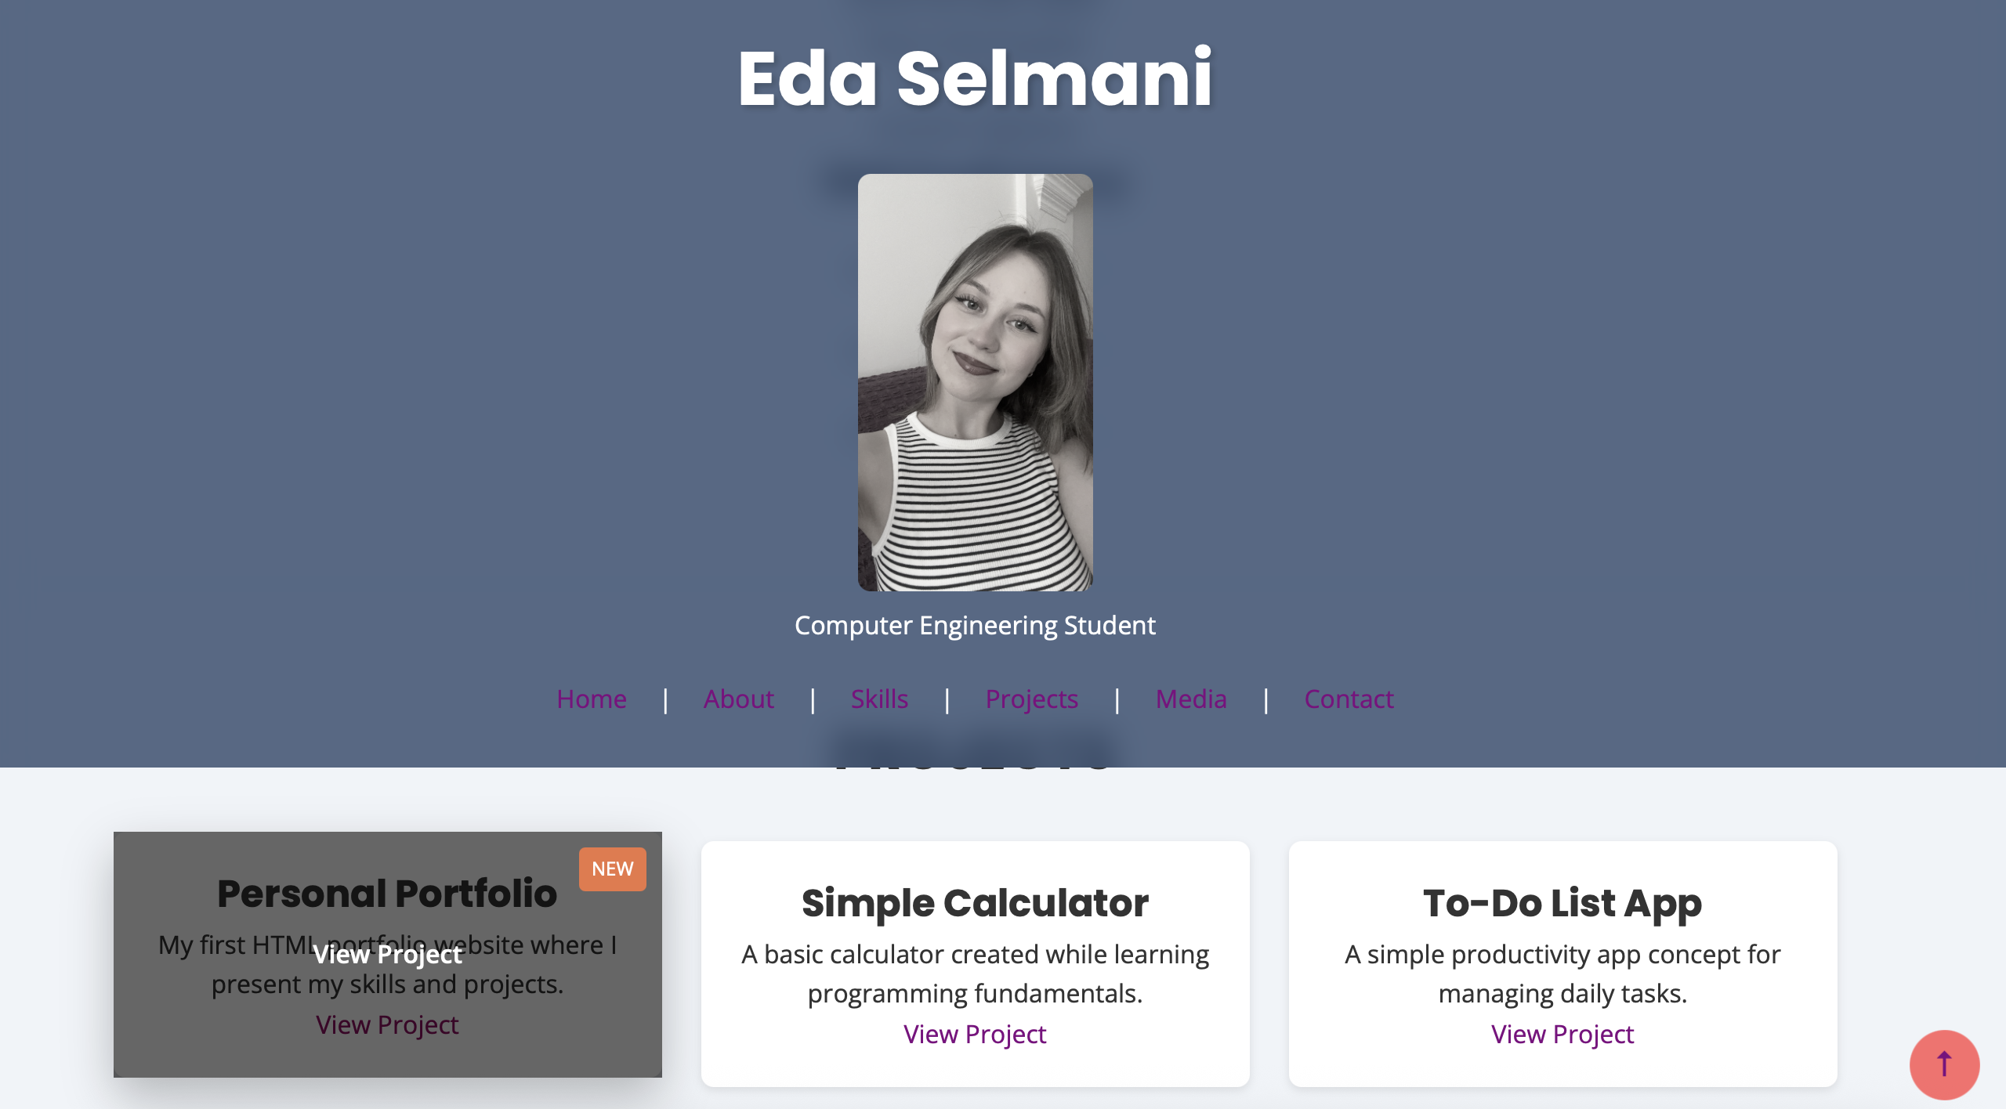
Exercise 11: Build a Complete Professional Layout
- Implement the full CSS reset at the top of your stylesheet.
- Add dark mode support using CSS variables and @media (prefers-color-scheme: dark).
- Make body use grid with grid-template-rows: auto 1fr auto so the footer always sticks to the bottom.
- Ensure every section has consistent vertical padding using your --space-xl variable.
- Test your dark mode by going to System Preferences → Appearance and toggling between Light and Dark mode.
- Add a .theme-toggle button with JavaScript that toggles a .dark class on <body> as a manual override.
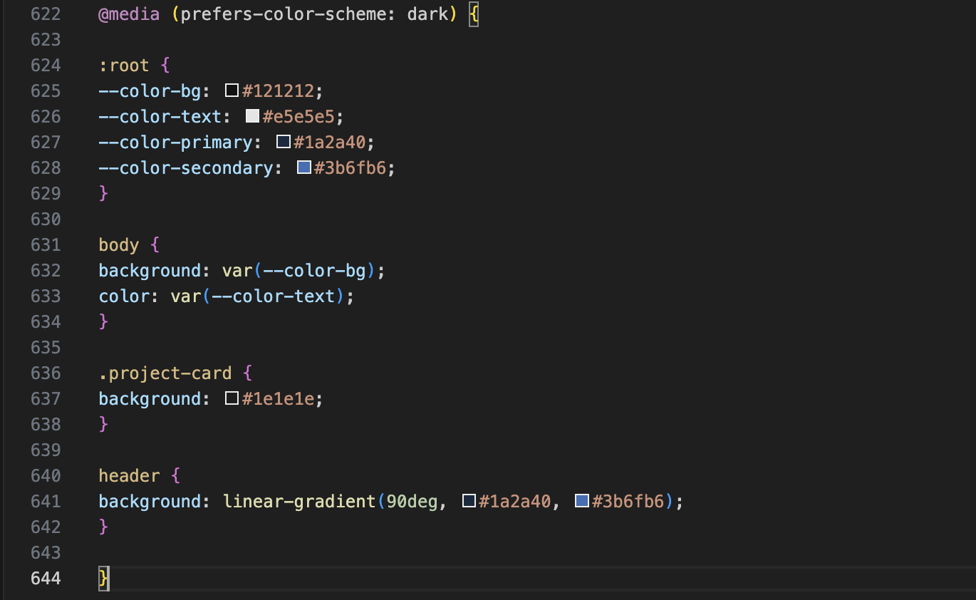
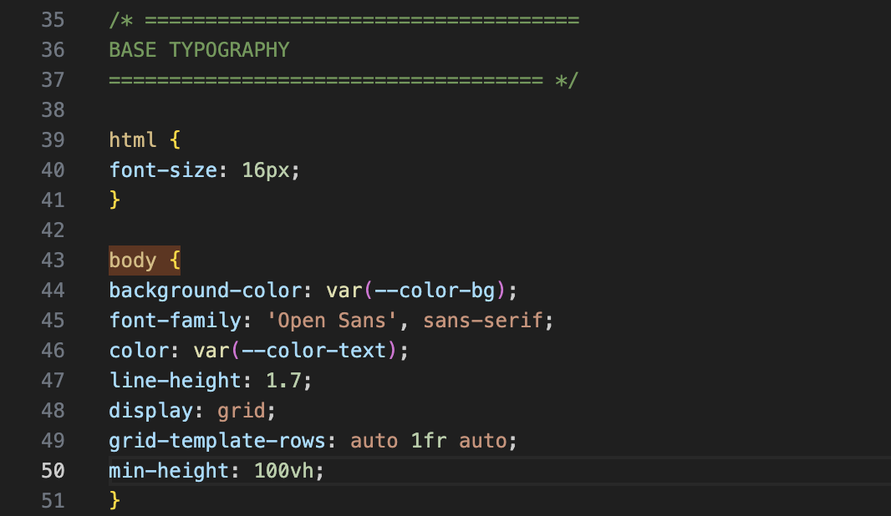
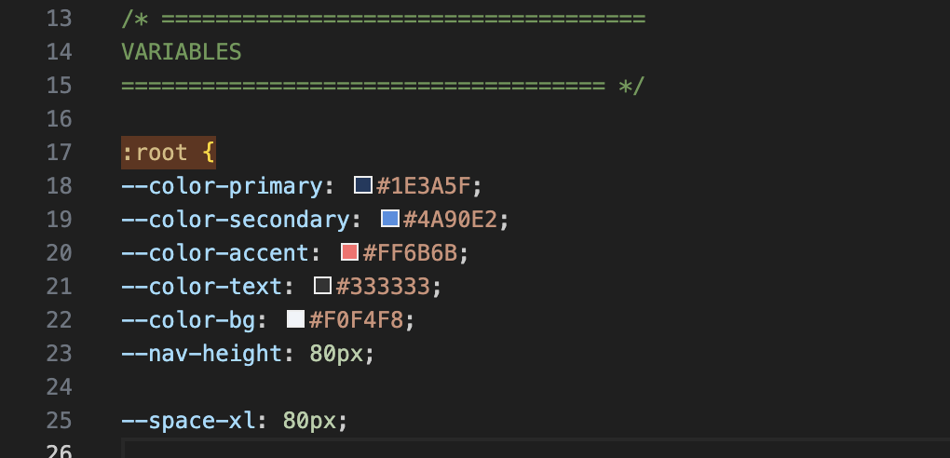
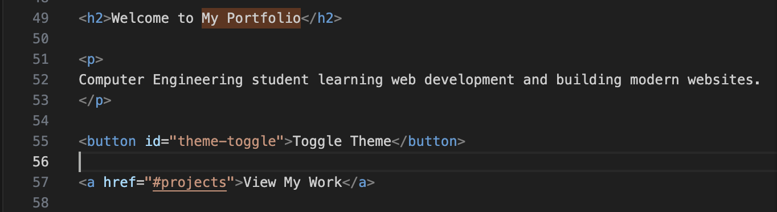
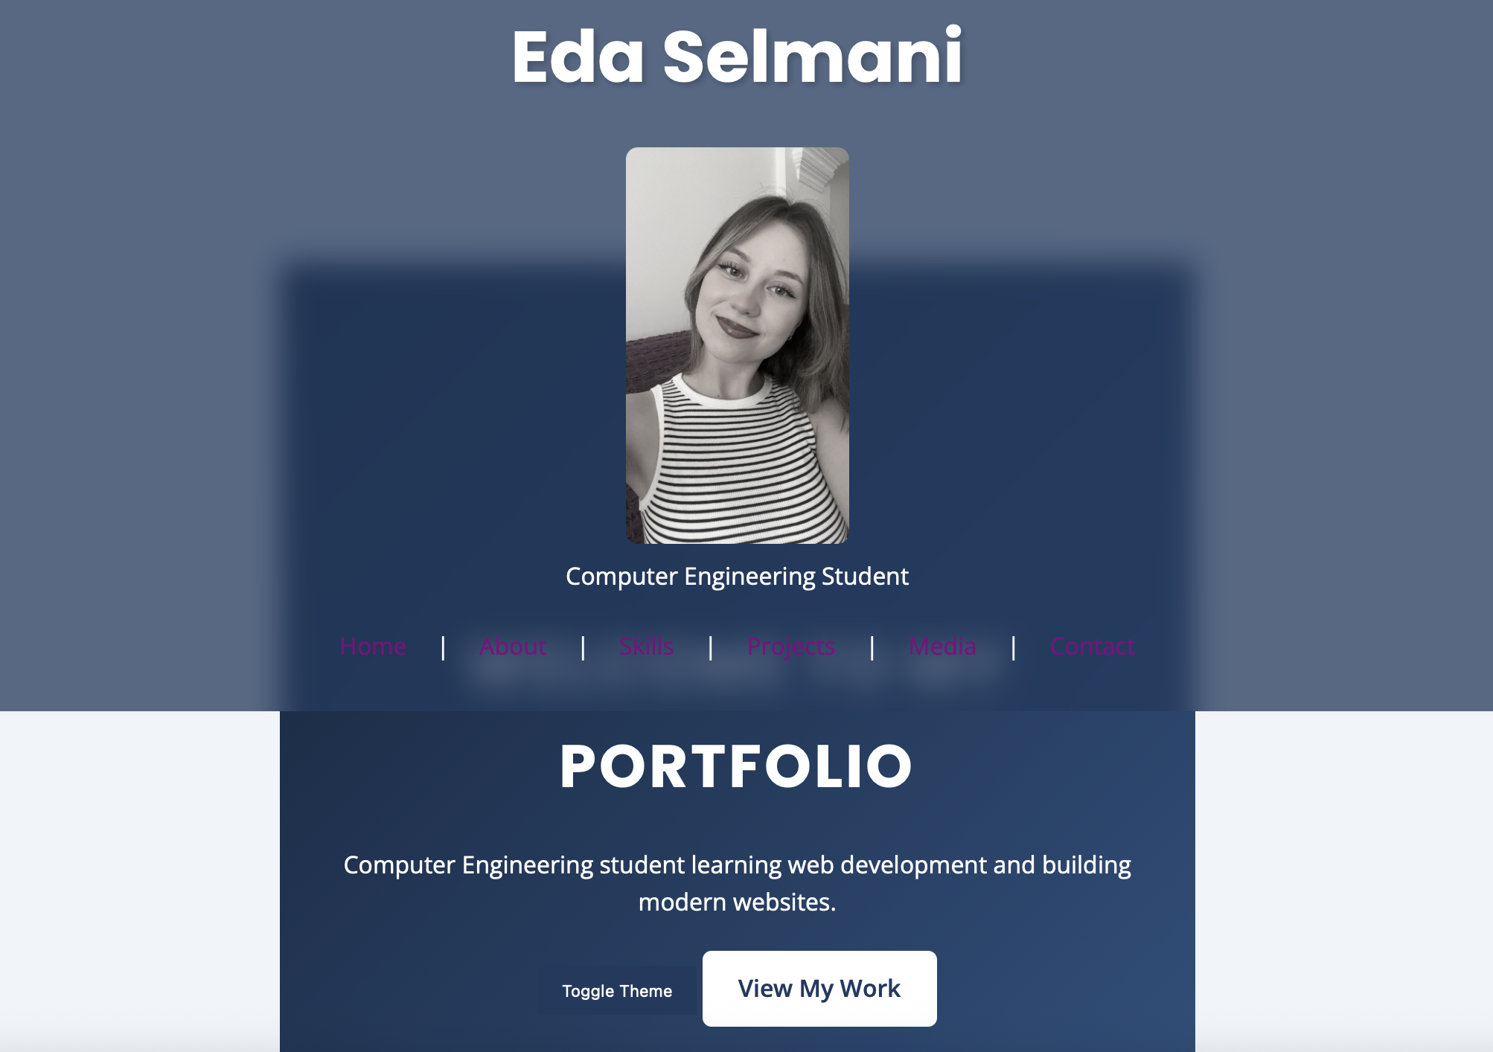
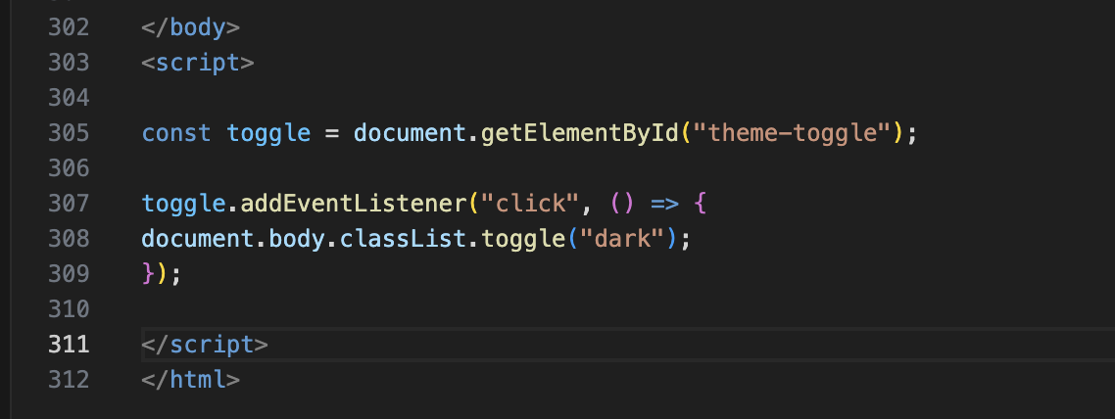
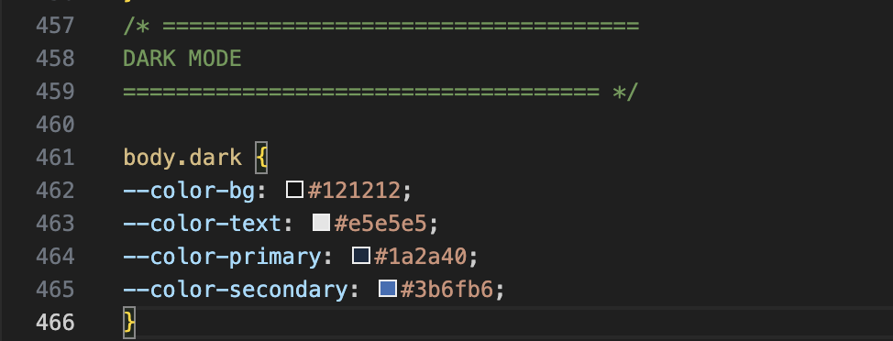

WHEN U CLICK TOGGLE GOES DARK MODE
